**Experiment 12: Develop a program to setup a UART protocol and pass a string through the protocol.**

**Date : 23.10.2025**

**Circuit:**

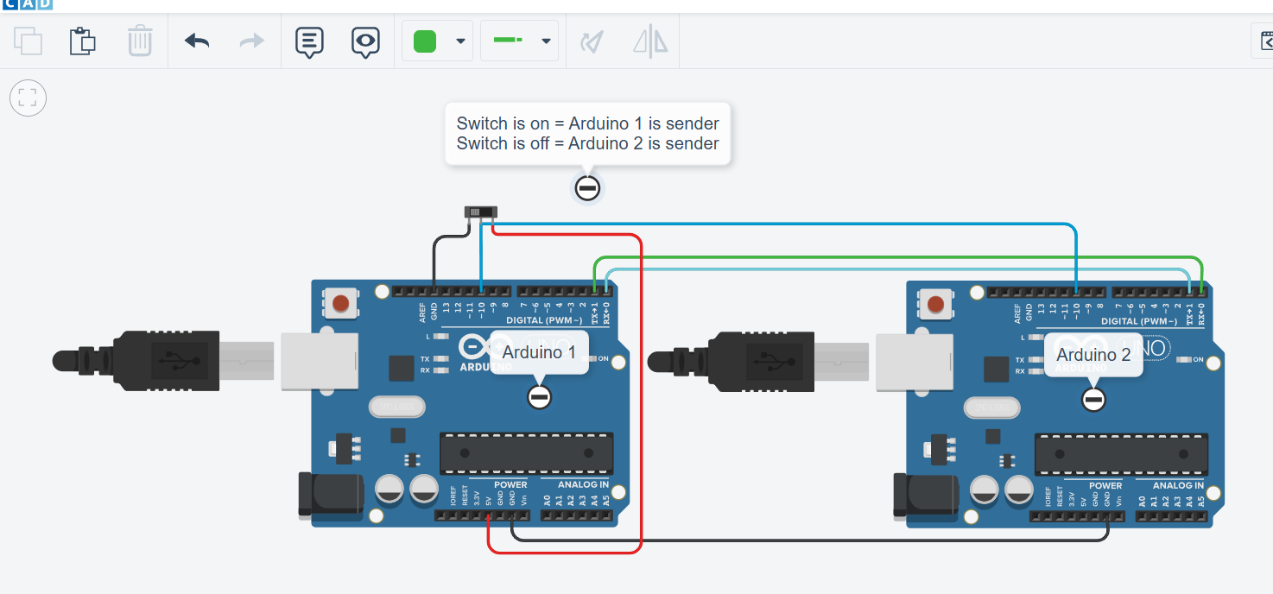

**Code:**

const int MAX_LEN = 100;

char send[MAX_LEN] = "IOT LAB FOR 7TH SEM\n";

char recieve[MAX_LEN];

int switch2 = 0; // Active LOW input

int switch_pin = 10;

void setup() {

Serial.begin(9600);

pinMode(switch_pin, INPUT);

}

void loop() {

switch2 = digitalRead(switch_pin);

if (switch2) {

// recieve if switch is on

int len = Serial.parseInt(); // read the length of string

char garbage = Serial.read();

Serial.readBytes(recieve, len); // read the string from the serial monitor.

Serial.print("Length = ");

Serial.println(len); // print the string length on serial monitor

Serial.print("Message = ");

Serial.println(recieve); // print the recieved message on serial monitor

delay(1000);

}

else {

// send if switch is off

int len = strlen(send);

Serial.println(len); // print/write the string length to the serial monitor

Serial.write(send, len); // write the string to the serial monitor

delay(1000);

}

}

**Output:**

